**Noble Team 9 - Major hub**

**ITSC 3155 Final Project Report**

**Alan Zhang**

**Chase Brock**

**Eyup Agirtmis**

**Jordan Schrodt**

**12/21/20**

**Table of Contents**

1 Introduction 2

1.1 Project Overview and Statement of Proposal 2

1.2 Project Scope and Objectives 2

2 Project Resources 3

2.1 Group Members 3

2.2 Hardware and Software Resources 3

2.3 Special Resources 3

3 Plan 4

3.1 Timeline chart 4

3.2 Task and Milestone Descriptions 4

3.3 2.3 Resource Table 4

4 System Design 5

4.1 Use Case Diagram 5

4.2 DFD Diagram 6

4.3 User Stories 6

4.4 Feature List 7

4.5 Storyboard 7

5 User Tests 8

5.1 User Tests and Result 8

5.2 Conclusion 9

6 Lessons Learned 9

7 Future Work 9

8 Appendices 10

8.1 Sketches 10

8.2 Software Repository 12

**1 Introduction**

Our team thought of the idea for this project by deciding on which of our selected data sets we thought to be the most useful and that we would use or would have valued in the past. All of us being current college students thought back to when we had to make the big decision of picking what major we wanted to pursue. It was a tough decision and we all wish we could’ve been more informed not only on what we picked but also on others. We believed that a database website that gave plenty of information and statistics on college majors would be very valuable in today's society.

**1.1 Project Overview and Statement of Proposal**

Our project “Major Hub” is designed to give financial, employment, and enrollment

information on the most common majors available today in an easy to understand website

format. The website will display information in a visualization format to easily compare and contrast between majors.

We propose to help people and college students learn about the costs and benefits of

getting a degree and avoiding potential debt after graduation.

**1.2 Project Scope and Objectives**

The primary aspect of the project would be to display every college major available and

its corresponding average annual pay. Another aspect that could be implemented into this

project would be a list of potential jobs attainable with each major. A concentration and

course list could be added as well so users can see the specifics needed to obtain their

chosen degree. I could also see adding an average debt to each corresponding major. Ideal

users of this data would be anyone who has an interest in college whether it’s returning,

upcoming, or current students. Societally wise this project would ideally help people to

stay out of debt, as many individuals who go through college go into debt through loans,

this dataset could help students navigate majors that would allow them to escape debt in

an easier fashion.

**2 Project Resources**

**2.1 Group Members**

Alan Zhang

Chase Brock  
 Eyup Agirtmis

Jordan Schrodt

**2.2 Hardware and Software Resources**

-Computer/Internet

-Django

-Excel/SQL

-CSV

-Pycharm

**2.3 Special Resources**

-Kaggle

-Github

-Google Docs

-Lucidchart

**3 Plan**

**3.1 Timeline Chart**

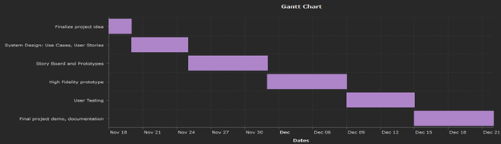

**3.2 Task/Milestone Descriptions**

Project Milestone 0: Expectations

Project Milestone 1: Finalize project idea

Project Milestone 2: User Stories and Use Cases

Project Milestone 3: Storyboard and prototype

Project Milestone 4: Review

Project Milestone 5: Project Testing

Project Milestone 6: Final Report and Demo

**3.3 Resource Table**

|  |  |
| --- | --- |
| **Task** | **People** |
| Finalize Project Idea | Alan, Eyup, Chase, and Jordan |
| Create User Stories | Alan, Eyup, Chase, and Jordan |
| Create Use Cases | Alan and Eyup |
| Create Storyboard | Chase and Jordan |
| Implement Prototype | Alan, Eyup, Chase, and Jordan |
| Initial Testing | Alan and Eyup |
| Implement high fidelity prototype | Alan, Eyup, Chase, and Jordan |
| User testing on HF prototype | Chase and Jordan |
| Documentation | Jordan |
| Final Project Demo | Alan and Chase |

**4 System Design**

**4.1 Use Case Diagram**

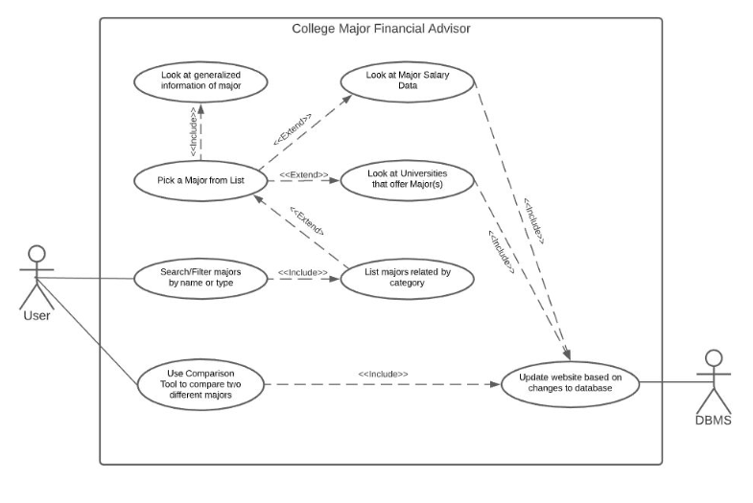

**4.2 DFD Diagram**

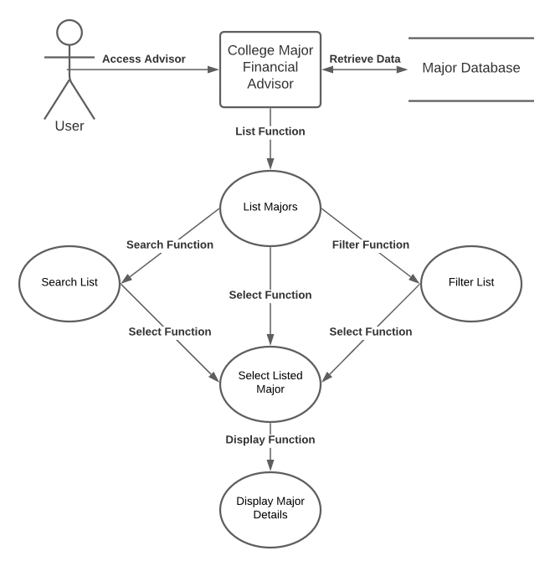

**4.3 User Stories**

-As a financial advisor I want to have the data to provide students and parents with the

most financially fitting major and school for them So that they can afford their schooling

while still getting a good learning experience.

-As a parent, I wish to help my child find a major that they are interested in that will also

provide them with a stable form of income for the future so they can have a better life

later on.

-As a student, I want to be able to browse for the majors with the highest pay so I can

plan for my future and which colleges I should attend.

-As a guidance counselor, I want to be able to access information about majors and their

benefits so that I can better guide my students.

**4.4 Feature List**

-List Majors

-Select Majors

-Display Salary Data

-Display Economic Data

-Display Highest Paying Majors

-Display Most Popular Majors

-Filter System

**4.5 Storyboard**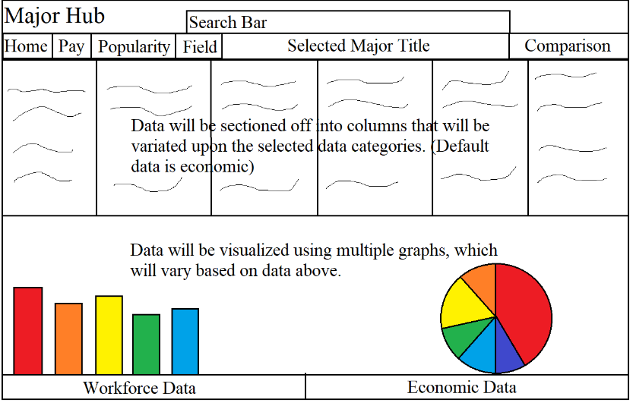

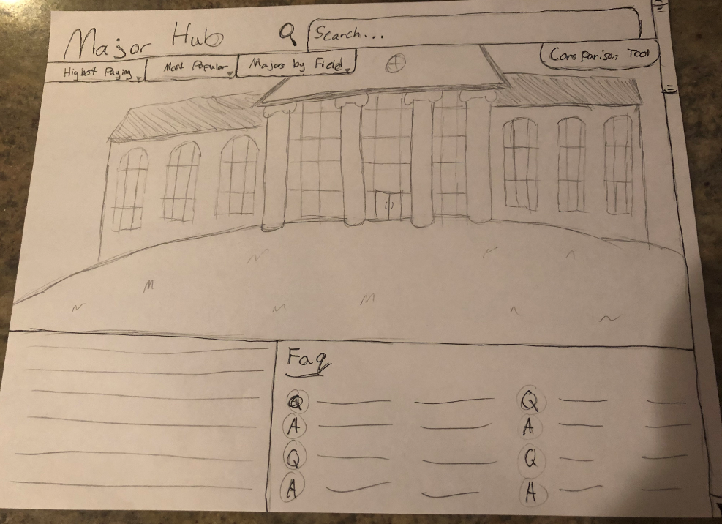

**5 User Tests**

**5.1 User Test and Results**

|  |  |  |
| --- | --- | --- |
| # | User Story | Results |
| 1 | As a user, I want to be able to search for a specific major, so I don’t have to look through an entire listing of majors. | Tester performed the action intuitively. |
| 2 | As a user, I want to contrast and compare 2 major's I am interested in to see which major would provide better financial security for me in the future. | Tester understood the concept of this action but couldn’t test correctly as the feature failed execution. |
| 3 | As a user, I want to view a list of majors in some form of categorical order, so I don't have to scour an entire list randomly. | Tester performed the action intuitively. |
| 4 | As a user, I need to see majors that are related to the one I have currently selected, so I can have an easier time viewing majors I might have an interest in. | Tester understood the concept of this action but couldn’t test correctly as the feature failed execution. |

**5.2 Conclusion**

Of the four test cases, the testing team completed two tasks intuitively. The other two

tests were classified as failures as they failed in their function, however, the testing team did understand what these features were supposed to do and why they were to be tested.

**6 Lessons Learned**

1. Make sure that ideas are applicable and realistic: Our team ended up having to cut a few planned features due to them not being realistic for our ship date.
2. Have more meetings or more meaningful meetings to make sure everyone is on the same page: We definitely spent more time than needed discussing how the website would be made due to use not having a central idea.
3. Create a more detailed timeline/schedule: Our workload ended up being much heavier towards the end of our development period due to us not understanding how much time should be allocated to what tasks.
4. Set aside more time for individual learning/research: As we began creating the projects we had to swap some of our roles due to us not having experience or knowledge in certain areas.
5. Establish more balance between brainstorming and development: Due to some of our inexperience with time management in this field we ended up starting the coding and development on this project too late to accomplish our goals.

**7 Future Work**

-Planned Comparison Tool

-Search Function/Tool

-Recommended University

-Recommended Minor

**8 Appendices**

**8.1 Sketches**

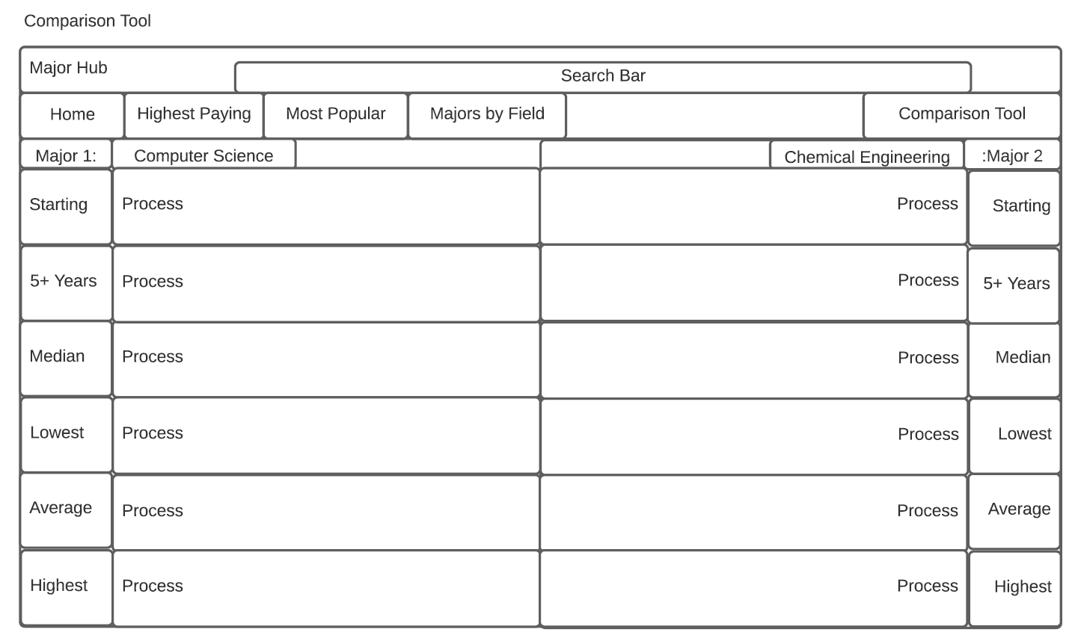

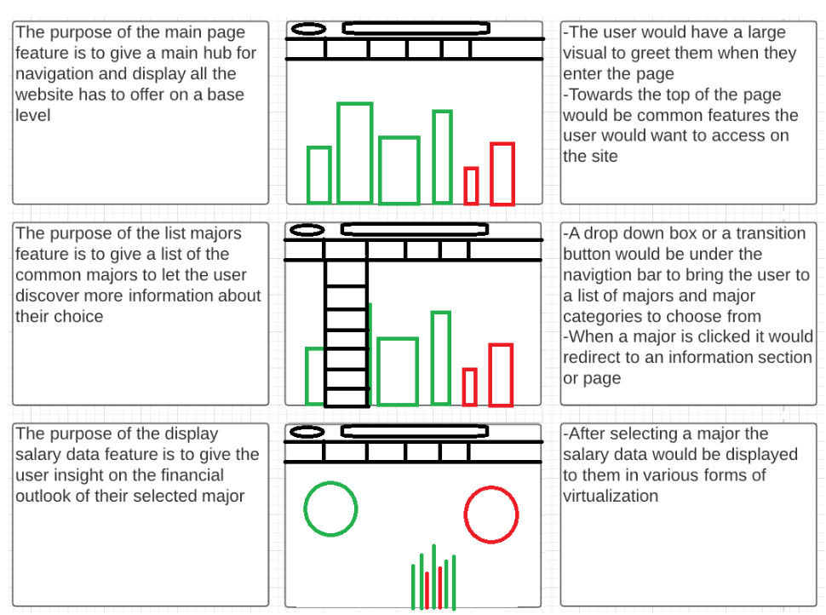

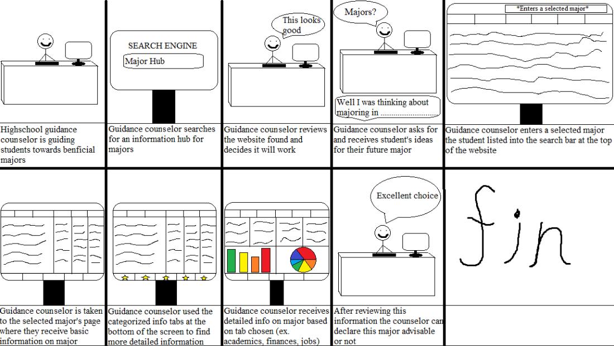

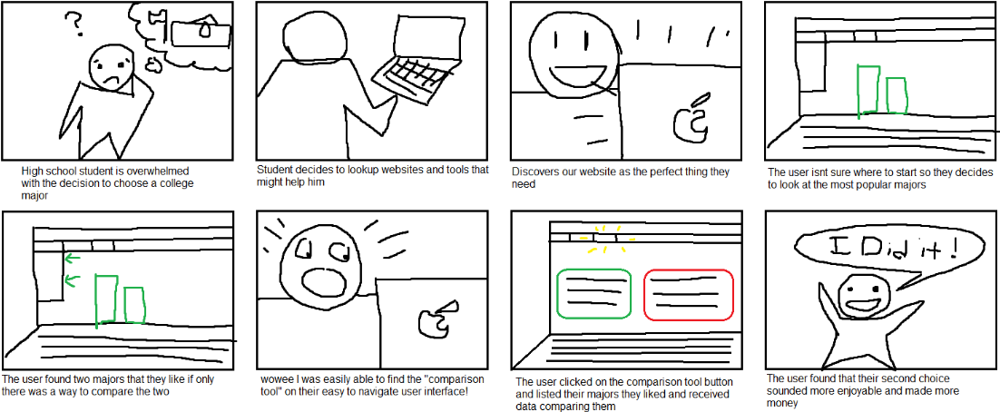

**8.2 Software Repository and Installation Instructions**

<https://github.com/eyagir/ITCS-3155-Team-9-Project> (Master Branch)

Instructions:

The packages below in the table are the packages we used for our development in the python virtual environment. Once installing these packages. You will have to run a python file to get the website up and running on [**http://127.0.0.1:8000/**](http://127.0.0.1:8000/)

The file is located major_hub/manage.py.

**python major_hub/manage.py runserver** from base directory or

**python manage.py runserver** the directory with the file in it

* Package Version
* ------------------------- -------
* asgiref 3.3.1
* Django 3.1.4
* numpy 1.19.4
* pandas 1.1.5
* pip 20.3.1
* plotly 4.14.1
* protobuf 3.14.0
* python-dateutil 2.8.1
* pytz 2020.4
* retrying 1.3.3
* setuptools 51.0.0
* six 1.15.0
* sqlparse 0.4.1
* wheel 0.36.1